# 

***BIMBO BAKING COMPANY***

***TASTE THE DIFFERENCE***



THE BAKING HEAVEN MAGAZINE

**TABLE OF**

**CONTENTS**

***ABOUT US…………………………………….................................................. 1***

***MISSION & VISION………...……………………………………………………………….2***

***CORE VALUES...…………………………………………………….….…………………….3***

***COMPLETED PROJECTS……………………………………………………………………4***

***UPCOMING PROJECTS…………………………………………………………………….5***

***ORGANISATIONAL CHART………………………………………………………………5***

***PRODUCTIVITY & SALES …………………………………………….………………….6***

***PRODUCTION PROCESS……………………………………………………….………...7***

***WORK FLOW……………………………………………………………………….………….7***

***MESSAGE FROM THE MANAGER…………………………………………………….8***

***MESSAGE FROM THE MARKETING MANAGER………………………………..9***

***MESSAGE FROM THE OPERATIONS MANAGER……………………………...***

About Us

***Bimbo Baking Company was founded by the Late Bagenda faiswal in 1999. It started small with a simple idea of selling more for less, but has grown into one of the largest baking companies in Uganda.***

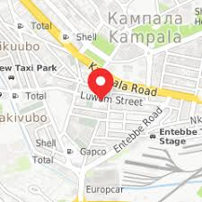

**THE LATE BAGENDA FAISWAL[FOUNDER]**

**B**imbo Baking Company has its main branch which is the main bakery at Nakaseke District, Central, region, Uganda.

|  |  |
| --- | --- |
| **Address** | : Bombo Road, Kampala, Uganda |
| **Coordinate** | :0.3309636, 32.5738999 |
| **Phone** | : +256 755 759078 |
| **Website** | : <http://www.bimbo.bakery.co.ug> |

**Company’s location [Map]** 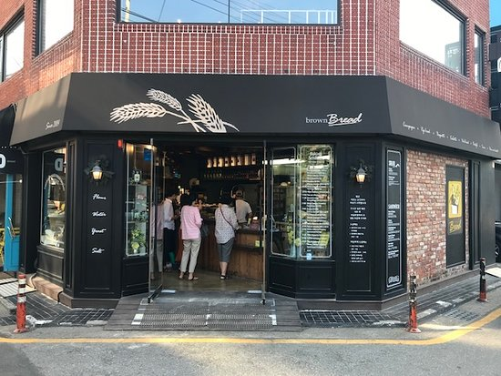

**Bimbo Baking Company Reception**

MISSION



***We, at Bimbo Baking Company are committed to be the leading Uganda manufacturer of wheat products. Create value for our stake holders by delivering quality products and services through continuous improvement, innovation and sustainable business practices.***

***We take pride in providing our customers with the goodness of distinctive tasting snacks and served fresh through our quality manufacturing and packaging technology that we continue to develop and improve.***

***We partner with customers towards a healthier life style and lead the food industry in a more beneficial snack alternative that also support the live hood of our local farmers.***

***We at Bimbo Baking company give our special attention in your health satisfaction.***

VISION



***To be the leading integrated and diversified global agribusiness providing quality and value-added products to customers worldwide.***

***We want to be known for our dedicated team of quality bakers and staff who use the best ingredients to deliver the best products.***

***Want to grow and improve our business in a sustainable manner.***

***We want to be recognized as a family business that continuously invests in the future through the development of its people, equipment and processes.***

CORE VALUES

***ONE OF OUR NEW PRODUCTS[HOSTESS]***



COMPLETED PROJECTS



***In the later years, Bimbo bakeries has been facing delivery issues where by we couldn’t transport and deliver our products to different parts of the country. This was because we lacked adequate delivery vans.***

**THE DELIVERY VANS WE HAD LATER BEFORE THIS YEAR**

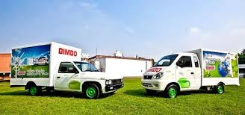

***Later on in late July, the company managed to purchase more six bigger delivery vans. These are to help in distributing our baking products in different parts of the country. This achievement/ project will surely increase the profit margins of Bimbo baking company in a shorter time.***



**The managing staff flagging of our knew delivery vans.**



The newly purchased delivery vans

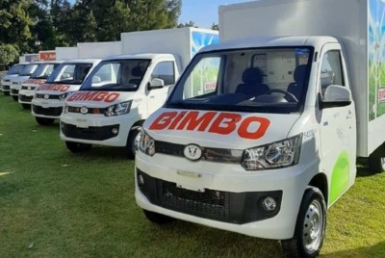

UPCOMING PROJECTS

***The management of Bimbo Baking Company is looking forward to completing more and more projects with the major aim of developing our company. We’re looking forward to creating branches all over the country to meet our mission and vision***.

***With the help of the almighty, this project will be done and achieved by the end of next year.***

ORGANISATIONAL CHART

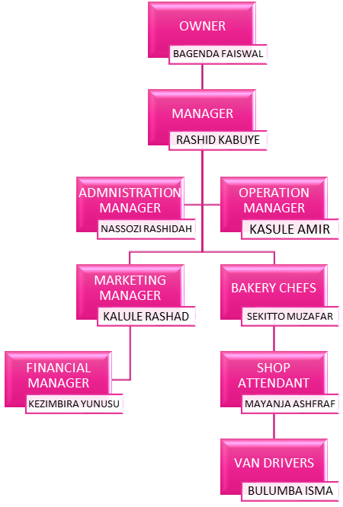

PRODUCTIIVITY & SALES

|  |  |  |
| --- | --- | --- |
| **Name**  **of product** | **Production**  **Cost** | **Production**  **Per day** |
| **Family Loaf** | **390000** | **500** |
| **Fancy Bread** | **420000** | **1000** |
| **Cup Cakes** | **350000** | **2000** |
| **Iced Cakes** | **1200000** | **300** |
| **Dounuts** | **210000** | **200** |
| **Fruit bread** | **250000** | **120** |

**OUR BEST CUP CAPES**



SALES

**BIMBO FAMILY BREAD**



**BIMBO FANCY BREAD**



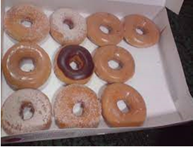



Production process

**Mixing ingredients except flour in required proportion in paste form**

**Preparing dough by mixing with flour**

**Placing dough in molding and cutting machine**

**Frying**

**Cooling and packing**

WORK FLOW

**CHEFS IN THE KNEADING & MOLDING PROCESS**

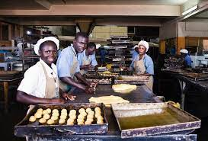

**FANCY BREAD BUNS HEADING TO THE COOLING PLACE**

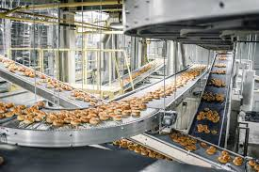

**FANCY BREAD DURING THE PACKING PROCESS**

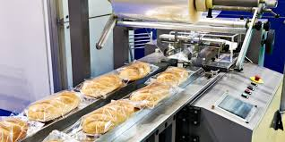

MESSAGE FROM THE MANAGER

**MR. KABUYE RASHID [COMPANY MANAGER]**



I thank all my employees for their effort in making the organization a successful one and bringing it to this position. I am really grateful for your painstaking effort in work. Thank you for everything you do to make this a successful, terrific place to work. I have been reflecting on the things I am most grateful for. Primarily among those is the talented group of employees. Thank you for the work you have done for the organization this year. You have helped us provide award-winning services to our clients. The organization has not only benefited from your service, you have also set a benchmark in customer service. Now that things have became smooth, I would believe that all of you would show the same patience. Such dedication is needed for the well-being of the company. Your willingness to take every challenge is admirable to me. Please continue with what you are doing and reach for better every day.

So, I want to thank you all for the hard work and commitment you’ve shown over the past year. Our combined strength is what makes us successful as a company.

I hope that when you’re celebrating the holidays with friends and family that you look back on the year with the same sense of accomplishment that we all should feel.

I wish you and your families all a happy holiday season.

Best regards,

Kabuye Rashid



BIBLOGRAPHY

Kagimu Rashad

Bimbo Baking Company (The baking heaven)

09th/01/2022 Kampala/Uganda GTM+5.

Nakaseke Bombo-road.

Lions Gate publishing company.

915 magazine copies

10 page[s]

.